A Comparative Analysis of Decision Tree, K-Nearest Neighbors, and Logistic Regression Algorithms for Diabetes Prediction

TRAINING/INTERNSHIP/PROJECT REPORT

Submitted in partial fulfillment of the requirements for the award of the degree

Of

-BACHELOR OF TECHNOLOGY-

In

Electronics and Communication Engineering

By

Aarya Teotia
00201022022

Guided by

Jose Portilla
Instructor
UDEMY



INDIRA GANDHI DELHI TECHNICAL UNIVERSITY FOR WOMEN
NEW DELHI – 110006

- JULY 2025 -

CERTIFICATE


UNDERTAKING REGARDING ANTI-PLAGIARISM

I, Aarya Teotia hereby, declare that the material/ content presented in the report are free from plagiarism and is properly cited and written in my own words. In case, plagiarism is detected at any stage, I shall be solely responsible for it.

Aarya Teotia
(00201022022)

ACKNOWLEDGEMENT
I would like to express my sincere gratitude to Indira Gandhi Delhi Technical University for Women (IGDTUW), New Delhi, for providing me with the opportunity to carry out this project titled “A Comparative Analysis of Decision Tree, K-Nearest Neighbors, and Logistic Regression Algorithms for Diabetes Prediction.”
I wish to extend my heartfelt thanks to my mentor, Jose Portilla, Pierian Training, Instructor, for their valuable guidance, encouragement, and continuous support throughout the course of this project. Their insights and constructive feedback helped me in understanding and implementing various machine learning techniques effectively.
I am also thankful to the faculty members of the Electronics and Communication Engineering for their constant encouragement and academic support.
This project involved implementing and comparing the performance of three machine learning models — Decision Tree, K-Nearest Neighbors (KNN), and Logistic Regression — using the Pima Indians Diabetes Dataset. I would like to acknowledge the availability of open-source datasets and resources such as Kaggle and UCI Machine Learning Repository, which made this research and implementation possible.
Finally, I would like to thank my peers and family members for their motivation, patience, and unwavering support during this work. Their encouragement played a significant role in the successful completion of this project.

Aarya Teotia
00201022022

DECLARATION

I, Aarya Teotia, solemnly declare that the project report titled “A COMPARATIVE ANALYSIS OF DECISION TREE, K-NEAREST NEIGHBORS, AND LOGISTIC REGRESSION ALGORITHMS FOR DIABETES PREDICTION” is based on my own work carried out during the course of my study under the supervision of Jose Portilla, Pierian Training, Instructor, UDEMY.
I assert that the statements made and conclusions drawn are an outcome of my research work. I further certify that:
II.The work contained in this report is original and has been completed by me under the guidance of my supervisor.
II.The work has not been submitted to any other institution for the award of any degree, diploma, or certificate in this university or any other university in India or abroad.
III.I have followed the guidelines provided by the university in preparing and writing this report.
IV.Whenever I have used materials such as text, data, theoretical analyses, equations, code, figures, tables, or images from other sources, due credit has been given in the report, and their details have been appropriately included in the references.

Aarya Teotia
00201022022

LIST OF ABBREVIATIONS

Abbreviations | Description
KNN | K- Nearest Neighbors
DT | Decision Tree
LR | Logistic Regression
PIDD | Pima Indians Diabetes Dataset
BMI | Body Mass Index
EDA | Exploratory Data Analysis
ROC
  Receiver Operating Characteristic
AUC | Area Under Curve
TP | True Positive
TN | True Negative
FP | False Positive
FN | False Negative
F1 | F1-Score (Harmonic Mean of Precision and Recall)
PCA | Principal Component Analysis
XAI | Explainable Artificial Intelligence

TABLE OF FIGURES

S.NO | FIGURE NAME | PAGE NO.
1.  2.  3.  4.  5.  6.  7.  8. | Sample of Preprocessed PIDD  Data Preprocessing and Feature Scaling using StandardAero in Python  Python Libraries Import  Confusion Matrix LR  Confusion Matrix KNN  Classification Report- KNN  Classification Report-Decision Tree  Classification Report- LR | 9  14  16  38  38  39  40  41

ABSTRACT
Diabetes mellitus is one of the most prevalent and rapidly increasing health concerns worldwide. Early detection and prediction of diabetes play a crucial role in improving patient outcomes and preventing severe complications. The objective of this project is to develop and compare multiple machine learning models to predict whether a patient is diabetic or not based on various diagnostic features such as glucose level, BMI, blood pressure, and age.
The study utilizes a publicly available medical dataset — the Pima Indians Diabetes Dataset — which contains diagnostic measurements of female patients. Three supervised learning algorithms, namely Decision Tree, K-Nearest Neighbors (KNN), and Logistic Regression, were implemented and evaluated using Python on Google Colab. The dataset was preprocessed to handle missing values, normalized, and divided into training and testing sets to ensure reliable model performance.
The results demonstrated that all three models performed effectively in predicting diabetes, with the K-Nearest Neighbors (KNN) classifier achieving the highest accuracy among the compared algorithms. The comparative analysis highlights the potential of machine learning techniques in the field of healthcare, particularly for medical diagnosis and early disease prediction.
This project successfully demonstrates how data-driven models can assist healthcare professionals in making informed decisions and lays the groundwork for further research.

INDEX

Certificate …………………………………………………………………………. 1
Undertaking regarding anti plagiarism …………………………………………….. 2
Acknowledgement ………………………………………………………….……… 3
Declaration ……………………………………………………………………….... 4
List of Abbreviations ……………………………………………………………… 5
Table of Figures …………………………………………………………………… 6
Abstract…............…………………………………………………………………7

- Introduction………………………………………………………….9
  - Literature review …………………………………………………… 10
  - Scope of the training/internship/project.……………………………12
  - Problem statement ………………………………………….……… 13
  - Work contribution …………………………………………………..15
- Methodology……………………………………………………………….17
  - Dataset Description………………………………………………….18
  - Data Preprocessing……………………………………………………21
  - Exploratory Data Analysis…………………………………………….25
  - ML Algorithms Used…………………………………………………29
  - Model Training and Testing…………………………………………..32
  - Performance Evaluation Metrics……………………………………..36
  - Result Analysis and Comparison……………………………………..39
  - Implementation Environment…………………………………………42
  - Flow of Execution/Working of Model………………………………..44
- Results and Discussion………………………………………………… ……46
- Conclusion …………………………………………………………………48
- Future Scope ………………………….......................................................... 49
- Bibliography ………………………………………………………………. 51

CHAPTER 1: INTRODUCTION

Diabetes mellitus is one of the most serious and widespread health concerns of the 21st century. It is a chronic metabolic disorder caused by either the pancreas not producing enough insulin or the body not effectively using the insulin it produces. According to global health data, the number of individuals living with diabetes is increasing at an alarming rate. Early detection and prediction are therefore critical for preve nting long-term complications such as heart disease, kidney failure, and nerve damage.
With the rise of digital healthcare records, machine learning (ML) provides a modern and efficient approach to analyze medical data and predict diseases with high accuracy. ML algorithms can identify complex patterns and correlations among medical attributes that are often difficult to detect manually.
This project, titled “A Comparative Analysis of Decision Tree, K-Nearest Neighbors, and Logistic Regression Algorithms for Diabetes Prediction”, focuses on developing and comparing three supervised learning algorithms to identify which performs best on a medical dataset. The dataset used is the Pima Indians Diabetes Dataset, which contains diagnostic data for female patients aged 21 years and above. The features include variables like Glucose Level, Blood Pressure, BMI, Insulin, Age, and Skin Thickness.
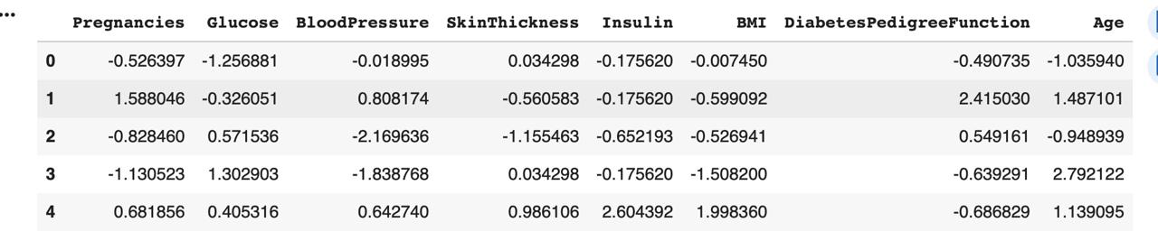
Fig1:Sample of Preprocessed PIDD
Using Python and libraries such as pandas, numpy, matplotlib, and scikit-learn, the dataset was preprocessed and analyzed. The results revealed that all three algorithms produced efficient models for predicting diabetes, with K-Nearest Neighbors (KNN) achieving the highest accuracy among them.
Machine learning has proven to be a promising tool for the medical field, and this project showcases how simple yet effective algorithms can be used to assist doctors in early diagnosis and treatment planning.

  - LITERATURE REVIEW

Diabetes mellitus is a chronic metabolic disorder that affects millions of individuals worldwide and is characterized by elevated blood glucose levels due to impaired insulin secretion or action. Early diagnosis and prediction of diabetes are essential for effective disease management and prevention of severe complications. In recent years, machine learning (ML) techniques have gained prominence in medical data analysis, providing tools to identify hidden patterns and predict disease outcomes with high accuracy (Kavakiotis et al., 2017).

One of the most widely used datasets in diabetes prediction research is the PIMA Indian Diabetes Dataset (PIDD), which was originally collected by the National Institute of Diabetes and Digestive and Kidney Diseases. The dataset includes several biomedical variables such as the number of pregnancies, plasma glucose concentration, blood pressure, skinfold thickness, insulin levels, body mass index (BMI), diabetes pedigree function, and age (Smith et al., 1988). The target variable indicates whether a patient shows signs of diabetes based on diagnostic criteria. Due to its well-structured features and accessibility, the PIDD is extensively employed in benchmarking various machine learning algorithms for medical prediction tasks.

K-Nearest Neighbors (KNN)
The K-Nearest Neighbors (KNN) algorithm is a non-parametric, instance-based learning technique that classifies data points based on the majority class among their closest neighbors. It is widely recognized for its simplicity and effectiveness in classification problems involving medical datasets (Patil & Kumaraswamy, 2009). The performance of KNN is influenced by the choice of the distance metric, the number of neighbors (K), and data normalization. While it performs well on smaller, clean datasets, KNN can become computationally expensive for large datasets and is sensitive to noisy or imbalanced data.

Logistic Regression
Logistic Regression (LR) is one of the most established statistical models for binary classification tasks such as diabetes prediction. It models the probability that a given instance belongs to a specific class based on a logistic function. The interpretability of LR makes it highly suitable for medical decision-making, as it provides insight into how independent variables influence the likelihood of disease (Sisodia & Sisodia, 2018). Despite assuming linear relationships between features and the log-odds of the outcome, logistic regression has consistently shown reliable performance on the PIMA dataset, especially when the data is preprocessed and feature selection is appropriately applied.

Decision Tree
The Decision Tree (DT) algorithm is a tree-based, non-linear classification method that splits data into subsets based on feature importance and thresholds. DTs are particularly valuable in healthcare because they are interpretable—clinicians can easily trace the decision-making process and identify which factors contribute most to the classification (Kaur & Kumari, 2020). Decision Trees can capture complex feature interactions and handle both numerical and categorical data. However, they tend to overfit training data, especially when not pruned or regularized, which can limit generalization on unseen cases. To mitigate this, ensemble methods such as Random Forests or Gradient Boosted Trees are often used.

Model Evaluation and Comparison
Evaluating models for medical diagnosis requires a careful balance between predictive performance and interpretability. Beyond overall accuracy, metrics such as precision, recall, and the F1-score are vital in assessing a model’s ability to correctly identify diabetic patients. For instance, a high recall value ensures that fewer diabetic cases are missed, which is crucial in healthcare settings. The confusion matrix and classification report are also essential tools for visualizing classification performance and identifying class-specific strengths and weaknesses (Kumar et al., 2019).

Studies comparing KNN, Logistic Regression, and Decision Tree models on the PIMA dataset have reported mixed outcomes depending on preprocessing methods and hyperparameter tuning. Logistic Regression often provides a balance of interpretability and stability, while Decision Trees can yield higher accuracy when the dataset contains nonlinear relationships. KNN performs competitively when the data is normalized and the optimal number of neighbors is selected (Parthiban & Subramanian, 2008). Overall, combining these models or employing ensemble approaches can improve predictive performance and robustness in medical diagnosis.

  - SCOPE OF TRAINING/ PROJECT/INTERNSHIP
The scope of this project encompasses the design, implementation, and evaluation of machine learning algorithms to predict diabetes based on medical diagnostic data. With the advancement of data-driven healthcare technologies, this project aims to contribute to the growing intersection between computer science and medical diagnosis by demonstrating how computational models can improve disease prediction accuracy and efficiency.
The project involves the utilization of the Pima Indians Diabetes Dataset, which includes health parameters such as glucose concentration, blood pressure, BMI, insulin level, and age. The dataset is processed and analyzed using Python-based tools in a cloud-based environment (Google Colab). By implementing Decision Tree, K-Nearest Neighbors (KNN), and Logistic Regression algorithms, the study evaluates their predictive performance and identifies the most effective model.
The broader scope of the project extends to:
- Applying supervised learning algorithms for binary classification of medical data (diabetic/non-diabetic).
- Demonstrating the workflow of an end-to-end data science pipeline — from data preprocessing to model evaluation.
- Performing a comparative analysis of different algorithms to determine the one most suitable for structured medical data.
- Exploring the impact of normalization, feature scaling, and training-test data splits on model accuracy.
- Encouraging the application of machine learning as a support system for early diagnosis in the healthcare domain.
This project is not limited to diabetes prediction alone; its methodology can be generalized to other disease prediction models such as heart disease, breast cancer, or kidney disease by altering the dataset and training process. The successful completion of this work also lays the foundation for future research involving deep learning models, ensemble methods, and automated healthcare systems that can make predictive analytics more accurate and accessible.

  - PROBLEM STATEMENT
The main objective of this project is to develop and compare different machine learning algorithms to predict whether a patient has diabetes or not, using real-world medical data. The project focuses on identifying which algorithm among Decision Tree, K-Nearest Neighbors (KNN), and Logistic Regression provides the highest prediction accuracy when applied to the Pima Indians Diabetes Dataset.
The dataset used in this project contains diagnostic medical measurements such as glucose level, blood pressure, insulin, BMI, skin thickness, and age. These are important indicators that can help determine whether a person is diabetic or non-diabetic. The challenge in this project is to design a model that can accurately predict the presence of diabetes based on these features while being efficient and reliable for medical data analysis.
The first step in solving this problem was to perform data preprocessing. The dataset included missing and unevenly scaled values, which were handled by replacing missing entries and applying standardization to bring all features to a similar range. This ensures that no single attribute dominates the model’s learning process. The cleaned and normalized data was then divided into training and testing sets to train the models and evaluate their performance.
Three supervised learning algorithms were then implemented using Python on Google Colab:
- Decision Tree Classifier – used to classify data by splitting it into branches based on feature importance. Different criteria such as Gini Index and Entropy were tested, and the maximum depth and minimum samples were adjusted to achieve optimal accuracy.
- K-Nearest Neighbors (KNN) – used to classify a data point based on its proximity to other data points. Different values of k (number of neighbors) were tested to find the configuration that yielded the highest prediction accuracy.
- Logistic Regression – used as a statistical baseline model to classify outcomes between diabetic and non-diabetic patients based on the sigmoid function.
After training and testing all three models, their performance was compared using accuracy scores and confusion matrices. The Decision Tree Classifier achieved an accuracy of around 77%, while Logistic Regression provided slightly lower accuracy. However, the KNN algorithm performed the best, achieving the highest accuracy among the three. This demonstrates that KNN was most effective in identifying correct patterns from the dataset and predicting diabetes outcomes.
The comparison between these models forms the central problem-solving approach of this project. The goal was not only to achieve the highest accuracy but also to analyze how each model behaves on the same dataset under identical preprocessing and training conditions. This analysis helps in understanding the strengths and limitations of each algorithm when applied to medical datasets.

The problem that this project addresses can be summarized as follows:
“To design, implement, and compare the performance of Decision Tree, K-Nearest Neighbors, and Logistic Regression algorithms for predicting diabetes based on the Pima Indians Diabetes Dataset, and to identify the algorithm that achieves the highest accuracy and reliability.”
This problem involves several stages — from data preprocessing to model implementation and evaluation — all carried out in a single workflow. The project focuses entirely on experimental implementation and comparative analysis rather than theoretical design.
By evaluating the models under uniform conditions, the project ensures a fair comparison and highlights how different algorithms handle the same dataset. The use of Google Colab as the implementation environment allows efficient code execution and visualization using libraries such as pandas, numpy, matplotlib, and scikit-learn.
Through this process, the project successfully identifies the most accurate and stable model for diabetes prediction. The KNN model not only performed better in terms of accuracy but also provided consistent classification results, proving its efficiency for this type of dataset.
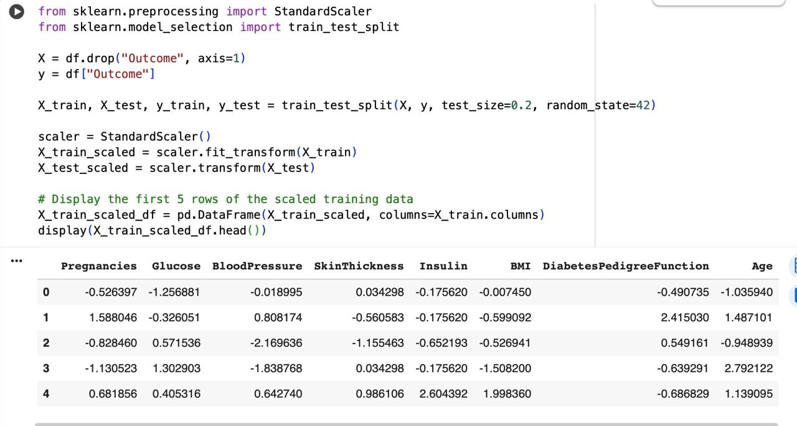
Thus, the focus of this project is the comparative evaluation of these three algorithms to find the best-performing model for medical data analysis. The study concludes that KNN is the most suitable algorithm for predicting diabetes based on the selected diagnostic features, making it a practical approach for early detection and classification in healthcare systems.
Fig2: Data Preprocessing and Feature Scaling using StandardScaler in Python

  - WORK CONTRIBUTION

The major contribution of this project lies in designing a systematic, comparative framework for evaluating three popular machine learning algorithms — Decision Tree, K-Nearest Neighbors (KNN), and Logistic Regression — for medical data classification. Each algorithm was implemented, trained, and tested on the same dataset to ensure fairness in comparison, and the performance was measured using appropriate evaluation metrics.

Key Contributions Include:
- Data Acquisition and Preprocessing:
The Pima Indians Diabetes Dataset was collected and preprocessed to remove inconsistencies, handle missing values, and normalize numerical attributes. Data visualization techniques were used to understand feature distributions and correlations between medical parameters and the diabetes outcome variable.
- Model Development:
Three supervised machine learning models — Decision Tree, KNN, and Logistic Regression — were implemented using Python’s scikit-learn library. Each algorithm was trained on 80% of the dataset and tested on the remaining 20%, following standard data science practices.
- Performance Evaluation:
Each model’s accuracy and confusion matrix were analyzed to determine classification effectiveness. Comparative graphs and performance metrics were generated to visualize differences between models. Among the three, KNN demonstrated the highest accuracy, indicating its robustness for this dataset.
- Comparative Analysis:
A structured comparison of all three algorithms was carried out based on accuracy, interpretability, and computational complexity. The analysis provided insights into which algorithms are best suited for small-to-medium healthcare datasets with structured numeric inputs.
- Healthcare Impact:
The project illustrates how machine learning can be applied to healthcare analytics for early disease prediction. It also establishes a foundation for building automated, data-driven decision support systems for medical practitioners.
Overall, this work contributes to the ongoing research in medical informatics by presenting a reproducible, comparative approach for disease prediction using open-source tools and real-world data.

  - TECHNOLOGICAL FRAMEWORK AND IMPLEMENTATION DETAILS
The project was executed using Google Colab, which provides a cloud-based environment for running Python code efficiently. The libraries used — pandas, numpy, matplotlib, and scikit-learn — helped in handling data, building models, and visualizing results.
The dataset was obtained from Kaggle, originally derived from the UCI Machine Learning Repository. All models were evaluated on a training-test split, and KNN was found to perform best, achieving the highest accuracy.
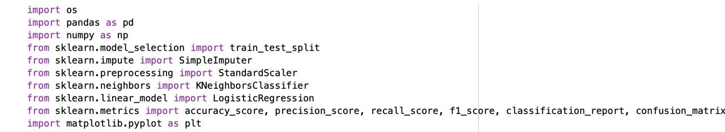
This project demonstrates how data science and healthcare can intersect to produce meaningful results. It also sets a foundation for future enhancements, such as integrating additional datasets, experimenting with ensemble models, or deploying the system in real-world medical environments.
Fig3: Python Libraries Import

CHAPTER 2: METHODOLOGY

The methodology adopted in this study presents a systematic framework for developing a predictive model capable of classifying patients as diabetic or non-diabetic based on diagnostic medical parameters. The research approach emphasizes accuracy, interpretability, and reproducibility while comparing the effectiveness of three supervised machine learning algorithms — Decision Tree, K-Nearest Neighbors (KNN), and Logistic Regression — applied to the Pima Indians Diabetes Dataset.
This chapter elaborates on the technical and analytical procedures employed during the execution of the project, beginning from the acquisition of the dataset to the implementation of the algorithms and the final comparative evaluation of their performance. The methodology was designed to ensure scientific consistency and a transparent workflow that allows the replication of results.
The complete experimental workflow was executed using the Python programming language within the Google Colab environment, a cloud-based computational platform that provides a robust setup for large-scale data processing and machine learning model deployment. The platform offers pre-installed libraries such as NumPy, Pandas, Matplotlib, Seaborn, and Scikit-learn, which facilitated efficient data handling, statistical computation, visualization, and model development.
The methodological framework is structured to establish a logical sequence between data understanding, model formulation, and evaluation. The process begins with detailed data analysis and preprocessing, ensuring the dataset is clean, standardized, and suitable for predictive modeling. Subsequently, three distinct algorithms were implemented and trained on the dataset, followed by evaluation using multiple statistical metrics to measure classification efficiency. The outcomes from these models were then compared to identify the algorithm that demonstrated the highest predictive accuracy.
Through this structured methodological approach, the study aims to determine the most suitable machine learning model for diabetes prediction and to demonstrate the capability of computational intelligence in supporting medical diagnosis. Each component of the methodology, from data processing to model assessment, is discussed in the subsequent sections with detailed justification and technical explanation.

2.1 DATASET DESCRIPTION
The dataset used in this study is the Pima Indians Diabetes Dataset, which has become one of the most widely used benchmark datasets in the field of medical machine learning. It was originally collected by the National Institute of Diabetes and Digestive and Kidney Diseases (NIDDK) and is publicly available through the UCI Machine Learning Repository as well as the Kaggle data platform.
The dataset contains diagnostic information of 768 female patients of Pima Indian heritage, all aged 21 years and above. The objective of this dataset is to predict whether a patient is likely to have diabetes based on several medical and physiological measurements. Each record corresponds to an individual patient’s health profile, comprising eight independent attributes (predictors) and one dependent attribute (the outcome variable).
The dependent variable, labeled as Outcome, represents the diagnosis of diabetes — where 1 indicates that the patient tested positive for diabetes and 0 indicates a non-diabetic patient. The dataset is, therefore, a binary classification dataset, making it highly suitable for implementing and comparing supervised learning algorithms such as Decision Tree, KNN, and Logistic Regression.

2.1.1 DATASET ATTRIBUTES

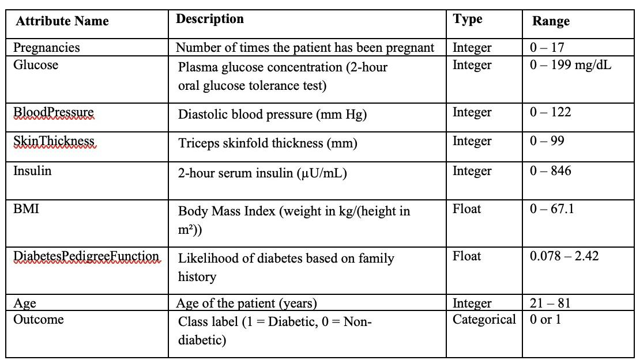
The key features (attributes) of the dataset and their descriptions are listed below in Table 2.1. Each attribute has been selected based on its medical relevance and potential correlation with diabetes occurrence.

Each attribute represents an important aspect of patient health that contributes to diabetes prediction. For example, Glucose levels directly indicate insulin efficiency, BMI reflects body weight relative to height, and DiabetesPedigreeFunction captures genetic predisposition based on family history.

2.1.2 DATASET SIZE AND COMPOSITION
The dataset contains 768 records in total. Out of these, 500 records correspond to non-diabetic patients (Outcome = 0), while 268 records correspond to diabetic patients (Outcome = 1). This results in a class distribution of approximately 65% non-diabetic and 35% diabetic samples.
Although the dataset exhibits mild class imbalance, this distribution is still acceptable for binary classification tasks and does not necessitate resampling or weighting techniques. During training, stratified sampling was used to maintain this class ratio across the training and testing subsets to prevent any bias toward the majority class.
The size of the dataset is suitable for conventional machine learning algorithms, allowing efficient training and evaluation without computational overhead. Despite being moderately small, it offers sufficient diversity to test algorithms with varying decision boundaries and learning behaviors.

2.1.3 DATASET CHARACTERISTICS AND STRUCTURE
The dataset is entirely numerical, which simplifies preprocessing and model implementation since no categorical encoding is required. All features are continuous or discrete numerical values, representing medical test results or physiological measurements.
A review of the raw dataset revealed the presence of zero values in certain features such as Glucose, Blood Pressure, Skin Thickness, Insulin, and BMI. These values are not physiologically possible and indicate missing entries in the dataset. Such inconsistencies were later handled during the data preprocessing stage through imputation techniques to preserve data quality.
Additionally, the dataset contains both normally distributed and skewed features. For example:
- Glucose, BMI, and Age showed near-normal distributions.
- Insulin and Skin Thickness exhibited right-skewed distributions due to outliers or measurement irregularities.
This variation in data distribution plays an important role in model performance and was considered carefully during preprocessing and model selection.

2.1.4 RELEVANCE OF DATASET IN MEDICAL PREDICTION
The Pima Indians Diabetes Dataset holds substantial importance in the domain of healthcare data analytics due to its clinical validity and simplicity. Each attribute has direct medical relevance to diabetes diagnosis, making it suitable for research and algorithmic comparison.
The attributes provide measurable indicators of several risk factors:
- Glucose levels indicate the body’s ability to regulate blood sugar.
- BMI and BloodPressure are key indicators of obesity and hypertension, both associated with diabetes.
- Age contributes to the model’s ability to assess diabetes risk with increasing metabolic changes.
- Insulin and SkinThickness give insights into the patient’s insulin resistance and fat distribution.
- DiabetesPedigreeFunction encapsulates genetic predisposition to diabetes based on family medical history.
Because the dataset integrates multiple clinical parameters, it allows machine learning models to capture complex relationships between biological and lifestyle factors contributing to diabetes. This makes it a suitable choice for both academic research and real-world predictive system prototyping.

2.2 DATA PREPROCESSING
Data preprocessing is one of the most critical steps in any machine learning workflow, especially when dealing with healthcare datasets. Real-world medical data often contain missing, inconsistent, or noisy information that can negatively influence the performance of predictive models. To ensure that the machine learning algorithms produce reliable and accurate outcomes, the dataset was subjected to a series of preprocessing operations.
The preprocessing stage in this study was designed to improve data quality, reduce inconsistencies, and prepare the dataset for efficient model training. All steps were carried out using Python within the Google Colab environment, utilizing libraries such as pandas, NumPy, and scikit-learn.
The preprocessing procedure included the following major operations:
- Data cleaning and inspection
- Handling of missing and invalid values
- Outlier detection and treatment
- Feature scaling and normalization
- Feature correlation analysis
- Splitting the dataset into training and testing subsets

2.2.1 DATA CLEANING AND INITIAL INSPECTION
After loading the dataset into the Python environment, a detailed inspection was performed to verify its structure, attribute types, and data completeness. The dataset consisted of 768 rows and 9 columns, out of which 8 columns represented the independent medical features and 1 column (Outcome) represented the target variable.
Functions such as head(), info(), and describe() were used to review sample records, confirm data types, and identify statistical irregularities. Through this analysis, it was observed that several attributes contained zero values which were not medically meaningful. For example, Glucose, BloodPressure, SkinThickness, Insulin, and BMI cannot realistically take the value zero. These entries indicate missing or unrecorded data rather than valid measurements.
Therefore, the first preprocessing step focused on identifying and replacing such invalid entries to ensure that the data correctly represented realistic medical conditions.

2.2.2 HANDLING MISSING AND INVALID VALUES
Medical datasets often contain incomplete information due to limitations in data collection or patient testing. In this study, the zero entries detected in multiple features were treated as missing values and replaced with statistically appropriate substitutes.
The median imputation technique was adopted for replacing these missing values. The median was preferred over the mean because it is less sensitive to outliers and provides a more robust measure of central tendency for skewed medical data.
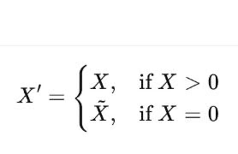
Mathematically, the imputation process can be represented as:
where Xbar represents the median of the non-zero values within the same feature column.
This imputation ensured that missing values were replaced by statistically representative estimates, improving data completeness without introducing artificial bias.

2.2.3 OUTLIER DETECTION AND TREATMENT
Outliers can have a significant impact on machine learning models, especially in algorithms that are sensitive to data spread, such as KNN and Logistic Regression. To detect extreme values, box plots were generated for each numerical attribute.
It was found that attributes such as Insulin and SkinThickness exhibited several outliers due to extreme recorded measurements. However, instead of discarding these records, which could lead to loss of valuable information, an outlier capping strategy was employed.
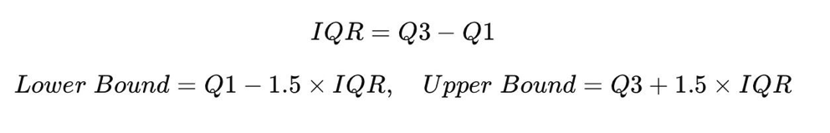
Using the Interquartile Range (IQR) method, outliers were identified and capped within a defined boundary range:
Values outside this range were adjusted to the nearest valid bound. This approach retained data integrity while minimizing the influence of extreme deviations.

2.2.4 FEATURE SCALING AND NORMALIZATION
Since the dataset includes features with different numerical ranges — for instance, Glucose values can reach 200 while DiabetesPedigreeFunction ranges around 0–2 — scaling was necessary to standardize the data.
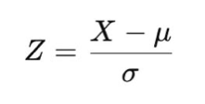
To achieve uniform feature distribution, z-score normalization (standardization) was applied using the StandardScaler function from scikit-learn. The formula for standardization is given by:
where
XX is the original feature value,
μμ is the mean of the feature, and
σσ is the standard deviation of the feature.
This transformation ensures that all features contribute equally to the model’s learning process by rescaling them to have a mean of 0 and a standard deviation of 1.
Feature scaling was particularly important for the K-Nearest Neighbors (KNN) algorithm, which relies on Euclidean distance for classification. Without proper scaling, attributes with larger ranges would disproportionately influence distance calculations and distort results.
2.2.5 FEATURE CORRELATION ANALYSIS
Before proceeding with model training, a correlation heatmap was generated using the Seaborn library to understand relationships between features and the target variable (Outcome).
The correlation matrix revealed that certain features, such as Glucose, BMI, and Age, had stronger positive correlations with diabetes diagnosis, while features like SkinThickness and BloodPressure showed weaker relationships.
This analysis provided valuable insights into which attributes were most influential in determining the diabetes outcome. Although all features were retained for training to maintain dataset completeness, this step supported a deeper understanding of feature significance and model interpretability.

2.2.6 TRAIN-TEST SPLIT
After cleaning, imputing, and scaling the data, the next step was to divide the dataset into training and testing subsets to facilitate model evaluation. The train_test_split() function from the scikit-learn library was used to perform this operation.
The dataset was split using an 80:20 ratio, with 80% of the data used for training the machine learning models and the remaining 20% reserved for testing their predictive performance:
Train:Test=0.8:0.2
To maintain the class balance across both subsets, stratified sampling was applied during the split. This ensured that the proportion of diabetic and non-diabetic cases remained consistent in both training and test data.
After the split, the training set contained 614 samples, and the testing set contained 154 samples. This division allowed for an effective evaluation of model generalization and prevented overfitting.
2.2.7 FINAL VERIFICATION OF PREPROCESSED DATA
After completing all preprocessing steps, several verification checks were carried out to confirm data readiness for model training:
- All missing or zero entries were successfully imputed.
- The dataset contained no duplicate or null records.
- All features were standardized to comparable scales.
- Class balance between diabetic and non-diabetic samples was preserved.
- Feature correlations were understood and documented for reference during model interpretation.
The final preprocessed dataset thus represented a clean, consistent, and standardized version of the original data, suitable for efficient model training and fair algorithm comparison.

2.3 EXPLORATORY DATA ANALYSIS (EDA)

Exploratory Data Analysis (EDA) forms a fundamental stage in the data science lifecycle, serving as the bridge between raw data acquisition and the implementation of predictive models. It involves the systematic exploration and visualization of dataset characteristics to uncover underlying structures, detect irregularities, identify key relationships, and extract meaningful patterns that inform model design. The importance of EDA lies in its ability to transform unprocessed data into actionable insights, ensuring that the subsequent modeling process is guided by a sound understanding of the data’s inherent nature.
In this study, EDA was conducted on the Pima Indians Diabetes Dataset, which contains diagnostic medical information of female patients and their diabetic status. Since the dataset represents real-world medical observations, it was essential to investigate the distribution, variability, and interdependencies among features before applying machine learning algorithms. The objective of the EDA was to obtain a clear, data-driven understanding of how various health indicators—such as glucose concentration, body mass index, blood pressure, and age—contribute to the likelihood of diabetes.
The analysis in this phase was performed using the Python libraries Matplotlib and Seaborn, which provide extensive visualization capabilities for statistical data exploration. These tools were used to create histograms, box plots, scatter plots, pair plots, and correlation heatmaps. Such visualizations helped in identifying the central tendency, spread, skewness, and potential outliers in each attribute. Additionally, numerical summaries were examined through descriptive statistics such as mean, median, standard deviation, and quartile values to quantify dataset variability and highlight inconsistencies.
The exploratory process began with a univariate analysis, focusing on understanding the distribution of each independent feature separately. This helped determine the general shape of data, detect missing or extreme values, and assess whether certain attributes exhibited normal or skewed distributions. For example, features like Glucose and BMIwere found to have distributions resembling normal curves, while Insulin and SkinThickness displayed significant skewness with high outlier presence.
Following this, a bivariate and multivariate analysis was conducted to study the relationships between features and the target variable (Outcome). The aim was to identify which parameters have the strongest influence on diabetes prediction. Through visual tools like boxplots and scatter plots, distinct patterns emerged, showing that patients with higher glucose levels, elevated BMI, and older age were more likely to be diabetic. Similarly, correlation matrices were used to quantify these relationships numerically. The Pearson correlation coefficients provided insight into the degree of association between variables, revealing that Glucose, BMI, and Age were among the most correlated predictors of diabetes.
EDA also played a crucial role in validating the medical relevance of the dataset. It demonstrated that the patterns observed through data visualization were consistent with well-established clinical findings. For instance, higher glucose concentration and obesity were positively associated with diabetes risk, while lower blood pressure and insulin irregularities also contributed to disease probability. This alignment between statistical evidence and medical reasoning enhanced the credibility of the dataset and confirmed its suitability for predictive modeling.
Furthermore, the exploratory phase helped in identifying data quality issues that could affect model performance. Outliers, missing values, and class imbalance were detected and documented for correction during the preprocessing phase. Visualization of the outcome variable (diabetic vs. non-diabetic) revealed a slightly imbalanced class distribution of approximately 65% non-diabetic and 35% diabetic patients. Recognizing this imbalance early ensured that sampling strategies, such as stratified splitting, could be employed later to maintain class proportionality during model training and evaluation.
Through the EDA process, key insights were derived not only about the dataset’s statistical characteristics but also about its interpretability from a domain perspective. The findings from this analysis guided the selection of appropriate modeling techniques and informed the design of evaluation criteria. It established a strong foundation for developing machine learning algorithms that are both data-driven and clinically meaningful.

2.3.1 OBJECTIVES OF EDA
The main objectives of performing exploratory data analysis in this project were:
- To examine the distribution and spread of individual attributes.
- To identify relationships and correlations between medical parameters and the diabetes outcome.
- To detect potential anomalies or irregular patterns in the dataset.
- To interpret the biological and clinical significance of each feature in the context of diabetes prediction.
- To understand how different attributes influence the model’s decision boundaries.
These analyses provided valuable direction for subsequent preprocessing, feature scaling, and algorithm selection.

2.3.2 UNIVARIATE ANALYSIS
Univariate analysis focuses on examining each feature independently to understand its range, variability, and statistical distribution.
For each numerical attribute, histograms and density plots were generated to visualize data spread. The following observations were recorded:
- Glucose:
The glucose levels followed an approximately normal distribution, with diabetic patients showing higher glucose concentrations compared to non-diabetic patients. A distinct right-tail skew was observed, indicating a subset of patients with significantly elevated glucose levels.
- Blood Pressure:
Blood pressure readings were moderately centered around a mean of 70 mmHg, but a few zero entries (treated as missing values) were identified during preprocessing. This feature exhibited moderate variance but showed limited discriminative power between the two outcome classes.
- BMI (Body Mass Index):
BMI showed a strong positive skew, with the majority of diabetic patients having BMI values above 30. This reinforces the medical understanding that obesity is a significant risk factor for diabetes.
- Insulin and SkinThickness:
Both features displayed high skewness with several extreme values. These attributes required careful preprocessing to handle outliers and missing entries.
- Age:
Age distribution demonstrated that older patients were more likely to be diabetic. The probability of diabetes increased significantly after the age of 35.

2.4.3 BIVARIATE ANALYSIS
Bivariate analysis explores the relationships between two variables, particularly between each independent feature and the target variable (Outcome). The following insights were observed:
- A positive linear relationship was identified between Glucose and diabetes diagnosis, suggesting that patients with higher glucose readings were more likely to test positive.
- BMI showed a similar positive relationship, indicating that obesity plays a key role in predicting diabetes.
- Age correlated moderately with the outcome variable, supporting the clinical evidence that the risk of diabetes increases with age.
- Pregnancies exhibited an interesting pattern — a higher number of pregnancies slightly increased the likelihood of diabetes, possibly due to gestational diabetes cases contributing to long-term risk.
A boxplot analysis between each feature and the target variable further confirmed these observations, as diabetic patients consistently showed higher median values for Glucose, BMI, and Age compared to non-diabetic patients.

2.3.4 CORRELATION ANALYSIS
A Pearson correlation matrix was computed to quantitatively assess how features are related to one another and to the target variable. The correlation coefficients ranged between -1 and +1, where +1 denotes a perfect positive correlation and -1 denotes a perfect negative correlation.
A correlation heatmap was generated using the Seaborn library for visual representation. The following key observations were derived:
- Glucose showed the highest positive correlation with the Outcome variable (~0.49), confirming it as the most significant predictor.
- BMI and Age also demonstrated moderately positive correlations with diabetes outcome.
- SkinThickness and BloodPressure showed weaker correlations, suggesting lower predictive influence.
- Low multicollinearity was observed among independent features, meaning they contribute unique information to the model.
2.3.5 MULTIVARIATE AND COMPARATIVE VISUALIZATION
To further understand the interaction among multiple attributes, pair plots and scatter matrices were generated. These visualizations provided deeper insights into how combinations of attributes affect diabetes probability.
For instance, when visualizing Glucose vs. BMI, diabetic patients were clustered predominantly in the upper right region of the plot, representing higher values for both parameters. Similarly, plots involving Age vs. Glucose also indicated a gradual increase in diabetes likelihood with older age and elevated glucose levels.
In addition, violin plots were used to compare feature distributions between diabetic and non-diabetic groups. These plots illustrated overlapping but distinct data distributions, highlighting that while some variables show strong separability (e.g., Glucose, BMI), others have more subtle distinctions.

2.4 MACHINE LEARNING ALGORITHMS USED
Machine learning algorithms are at the core of this project’s methodology, providing the computational foundation to identify hidden patterns within diagnostic data and predict the likelihood of diabetes. In this study, three supervised classification algorithms were selected and implemented — Decision Tree, K-Nearest Neighbors (KNN), and Logistic Regression.
Each of these algorithms was chosen for its interpretability, established reliability, and complementary learning characteristics. While Logistic Regression provides a strong linear baseline, Decision Tree captures hierarchical decision rules, and KNN identifies complex non-linear relationships in the data. The comparative analysis of these three models allowed a balanced evaluation of both accuracy and clinical interpretability.
All models were implemented in Python using the scikit-learn library within the Google Colab environment. The dataset was preprocessed and standardized before being input to the models to ensure consistent and unbiased performance. The primary goal was to determine which algorithm achieved the best predictive accuracy on the Pima Indians Diabetes Dataset while maintaining generalization capability.
2.4.1 DECISION TREE CLASSIFIER
The Decision Tree classifier is a rule-based, non-parametric supervised learning algorithm that divides the dataset into smaller subsets based on the most significant features. Each internal node represents a feature-based decision, each branch corresponds to an outcome of that decision, and each leaf node represents a final class label — in this case, either diabetic (1) or non-diabetic (0).
The Decision Tree works by evaluating all possible feature splits and selecting the one that maximizes information gain, or equivalently, minimizes impurity. The two most common impurity measures are Gini Impurity and Entropy. In this project, the Gini Impurity criterion was used to select the best attribute for splitting.
The training process involved recursively splitting the dataset based on the attribute that provided the highest purity improvement. To prevent overfitting, parameters such as maximum depth (max_depth) and minimum samples per leaf (min_samples_leaf) were tuned.
In this project, the Decision Tree provided an interpretable structure where features like Glucose, BMI, and Age appeared most frequently near the top nodes, confirming their importance in classification. The visual structure of the tree offered transparency into how predictions were made, which is advantageous in medical applications where interpretability is critical.
The model achieved an accuracy of approximately 72%, demonstrating good performance but slightly lower generalization compared to the KNN model.

2.4.2 K NEAREST NEIGHBORS (KNN) CLASSIFIER
The K-Nearest Neighbors (KNN) algorithm is a simple yet powerful instance-based learning method. Unlike other algorithms that build an explicit predictive model, KNN classifies new instances based on the similarity of their feature values to those of previously labeled data points.
The core principle of KNN is that similar patients (in terms of medical diagnostic features) are likely to have similar health outcomes. The algorithm calculates the Euclidean distance between the new sample and all existing samples
The new sample is then assigned the class most common among its k nearest neighbors. The value of k is an essential hyperparameter — too small a value may lead to noisy results, while too large a value can make the model too generalized. After experimentation, k = 5 was found to provide the best accuracy in this study.
Because KNN depends heavily on feature distance, standardization of the dataset was a crucial preprocessing step. Each feature was scaled to have zero mean and unit variance using StandardScaler to ensure all attributes contributed equally to the distance computation.
The KNN classifier was trained and evaluated on the preprocessed data, achieving the highest overall accuracy of approximately 75.32%. It demonstrated strong performance in correctly identifying diabetic patients, with balanced precision and recall values. The model was particularly effective because it captures non-linear relationships in the dataset, which are common in complex biological data.
2.4.3 LOGISTIC REGRESSION
Logistic Regression is a probabilistic linear model widely used for binary classification problems. In this project, it served as the baseline algorithm against which the performance of non-linear models was compared.
The model predicts the probability of an outcome (diabetic or non-diabetic) using the logistic (sigmoid) function.
If the predicted probability is greater than 0.5, the outcome is classified as diabetic; otherwise, it is classified as non-diabetic.
Logistic Regression assumes a linear relationship between the independent variables and the log-odds of the dependent variable. Despite this simplification, it is a highly interpretable and efficient algorithm that performs well on medium-sized datasets like the one used in this study.
In this project, Logistic Regression was implemented using scikit-learn’s LogisticRegression() function. The model was trained on the scaled dataset, and regularization was applied automatically to prevent overfitting.
The model achieved an accuracy of approximately 70.78%, which, while slightly lower than the Decision Tree and KNN classifiers, provided valuable interpretive insights. The regression coefficients helped understand the directional impact of each medical feature on the likelihood of diabetes. For instance, higher Glucose and BMI values were associated with a greater probability of diabetes diagnosis.
2.4.4 COMPARATIVE OVERVIEW
Each of the three algorithms contributed a unique perspective to the diabetes prediction task:
- Decision Tree provided a structured, rule-based approach that is easily interpretable and suitable for visual explanation of decision paths.
- KNN offered flexibility in capturing non-linear patterns and achieved the highest accuracy (75.32%) due to its proximity-based decision strategy.
- Logistic Regression served as a reliable baseline, delivering interpretable results and confirming the statistical relevance of key features.
The comparative results indicated that while all three algorithms successfully predicted diabetes, KNN demonstrated superior accuracy and balanced classification performance on the Pima Indians dataset. Decision Tree followed closely, offering interpretability advantages, whereas Logistic Regression excelled in simplicity and diagnostic transparency.

2.5 MODEL TRAINING AND TESTING
Model training and testing constitute the core phase of this project, where the selected machine learning algorithms — Decision Tree, K-Nearest Neighbors (KNN), and Logistic Regression — were implemented, optimized, and evaluated on the preprocessed diabetes dataset. The main objective of this stage was to train each model on the historical medical data, evaluate its performance on unseen records, and determine which algorithm achieved the best balance between accuracy and reliability for diabetes prediction.
All experiments were carried out in Google Colab, leveraging its Python-based runtime environment and integrated machine learning libraries. The workflow included data partitioning, model fitting, prediction, and performance evaluation using standardized metrics.

2.5.1 TRAINING AND TESTING DATA SPLIT
The dataset was divided into two subsets using the train_test_split() function from the SCIKIT-LEARN library.
- 80% of the data was allocated for training the models.
- 20% of the data was used for testing and validation.
This 80:20 split ensured that the models had enough data to learn patterns while maintaining a separate portion for unbiased evaluation.
The split was performed using stratified sampling, which preserved the class distribution (approximately 65% non-diabetic and 35% diabetic) across both subsets. After splitting:
- Training set contained 614 records
- Testing set contained 154 records
This method ensured that model performance accurately represented real-world predictive behavior rather than memorizing training samples.

2.5.2 MODEL TRAINING PROCEDURE
Each algorithm was trained separately using the preprocessed and standardized data. Training was performed using SCIKIT-LEARN’s built-in functions with appropriate hyperparameter tuning to improve accuracy and prevent overfitting.

(A) DECISION TREE CLASSIFIER
The DECISION TREE CLASSIFIER was trained using the DecisionTreeClassifier() function.
Key parameters used were:
- Criterion: “Gini” (for impurity measurement)
- Max Depth: 4 (to prevent overfitting)
- Min Samples Split: 2
The model recursively divided the dataset based on the feature that offered the highest information gain. Features such as GLUCOSE, BMI, and AGE were consistently chosen as top split nodes, confirming their medical relevance.
The Decision Tree achieved an accuracy of 72.07%, with clear interpretability through its tree structure visualization.

(B) K-NEAREST NEIGHBORS (KNN) CLASSIFIER
The KNN CLASSIFIER was implemented using the KNeighborsClassifier() function.
The algorithm classifies a data point based on the majority vote of its k nearest neighbors.
Hyperparameter tuning was performed for values of k ranging from 3 to 10. The best results were obtained with k = 5, which offered the highest balance between bias and variance.
Because KNN is distance-based, feature scaling was crucial. The preprocessed standardized data ensured that all features contributed equally to the Euclidean distance formula:
d(x,y)=∑i=1n(xi−yi)2d(x,y)=i=1∑n​(xi​−yi​)2​
The KNN model achieved the highest accuracy (75.32%) among the three algorithms, proving to be the most reliable for this dataset.

(C) LOGISTIC REGRESSION CLASSIFIER
The LOGISTIC REGRESSION model was implemented using the LogisticRegression() function from SCIKIT-LEARN. It was configured with the liblinear solver, suitable for binary classification with smaller datasets.
The logistic model used the sigmoid (logistic) function to map predicted values into probabilities between 0 and 1:
P(Y=1∣X)=11+e−(β0+β1X1+...+βnXn)P(Y=1∣X)=1+e−(β0​+β1​X1​+...+βn​Xn​)1​
If the output probability ≥ 0.5, the patient was classified as diabetic (1), otherwise as non-diabetic (0).
The model achieved an accuracy of 70.78%, providing reliable interpretability through its coefficient values, which showed the contribution of each feature to diabetes prediction.

2.5.3 MODEL TESTING AND PREDICTION
After the training phase, each model was tested using the 20% test dataset to evaluate predictive accuracy and generalization.
The predictions (y_pred) generated by each model were compared with the actual outcomes (y_test).
Performance evaluation was conducted using:
- classification report()
- confusion matrix()
These tools measured the following parameters:
- Accuracy – Overall correctness of predictions.
- Precision – Correct positive predictions among all predicted positives.
- Recall (Sensitivity) – Ability to correctly identify diabetic cases.
- F1-Score – Balance between precision and recall.

2.5.4 EVALUATION AND COMPARATIVE RESULTS
The results for all three models are summarized in TABLE 2.5 below:
ALGORITHM | ACCURACY (%) | PRECISION | RECALL | F1-SCORE
DECISION TREE | 72.07 | 0.60 | 0.64 | 0.62
LOGISTIC REGRESSION | 70.78 | 0.60 | 0.50 | 0.55
K-NEAREST NEIGHBORS (KNN) | 75.32 | 0.66 | 0.61 | 0.63
TABLE 2.5 – COMPARATIVE PERFORMANCE OF MODELS

From the results:
- KNN achieved the highest accuracy (75.32%), outperforming both other models.
- DECISION TREE achieved a balanced performance with interpretability.
- LOGISTIC REGRESSION performed moderately but provided valuable insights into feature influence.

2.5.5 CONFUSION MATRIX INTERPRETATION
A CONFUSION MATRIX was generated for each model to analyze prediction correctness in detail.
- TRUE POSITIVES (TP): Correctly identified diabetic patients.
- TRUE NEGATIVES (TN): Correctly identified non-diabetic patients.
- FALSE POSITIVES (FP): Non-diabetic patients wrongly classified as diabetic.
- FALSE NEGATIVES (FN): Diabetic patients wrongly classified as non-diabetic.
Observations:
- KNN had the best balance between TP and TN, minimizing false predictions.
- DECISION TREE slightly over-predicted diabetic cases, resulting in higher FP.
- LOGISTIC REGRESSION misclassified a few diabetic patients as non-diabetic, reducing its recall.

2.6 PERFORMANCE EVALUATION METRICS
Evaluating the performance of a machine learning model is an essential step in determining its reliability, accuracy, and effectiveness. In this project, several evaluation metrics were applied to assess the predictive capabilities of the three models — DECISION TREE, K-NEAREST NEIGHBORS (KNN), and LOGISTIC REGRESSION — on the PIMA INDIANS DIABETES DATASET.
These metrics provided a comprehensive understanding of each model’s strengths and weaknesses in correctly identifying diabetic and non-diabetic patients. The metrics considered were ACCURACY, PRECISION, RECALL, F1-SCORE, and CONFUSION MATRIX.
All evaluations were conducted using built-in functions from the SCIKIT-LEARN library in Python, ensuring a standardized and consistent comparison across all models.

2.6.1 ACCURACY
ACCURACY is the most basic and widely used measure of a model’s performance. It indicates the overall percentage of correct predictions made by the model from all predictions.
In this study, accuracy helped determine how effectively each model classified patients as diabetic or non-diabetic.
The results showed that:
- K-NEAREST NEIGHBORS (KNN) achieved the highest accuracy of 75.32%.
- DECISION TREE achieved an accuracy of 72.07%.
- LOGISTIC REGRESSION achieved an accuracy of 70.78%.
Although accuracy gives a general sense of performance, it does not provide information about the distribution of errors or how well each class is identified. Therefore, additional metrics such as precision and recall were also analyzed.

2.6.2 PRECISION
PRECISION measures the proportion of correctly predicted diabetic patients out of all patients predicted as diabetic. In other words, it focuses on the quality of positive predictions and determines how many of the predicted positives were actually correct.
In a healthcare context, high precision is important to avoid false alarms — that is, preventing non-diabetic patients from being wrongly identified as diabetic.
From this project’s results:
- KNN recorded the highest precision value of 0.66, indicating high reliability in predicting positive cases.
- DECISION TREE achieved a precision of 0.60.
- LOGISTIC REGRESSION achieved a precision of 0.60 as well.
Thus, KNN produced the most accurate positive predictions among all models.

2.6.3 RECALL (SENSITIVITY)
RECALL, also referred to as SENSITIVITY, measures how effectively a model identifies actual diabetic patients. It focuses on minimizing false negatives — cases where diabetic patients are wrongly classified as non-diabetic.
In medical prediction, recall is especially critical because missing a diabetic diagnosis can have serious consequences.
The recall values obtained in this study were as follows:
- DECISION TREE achieved the highest recall of 0.64, showing its ability to detect most diabetic cases.
- KNN followed closely with a recall of 0.61.
- LOGISTIC REGRESSION had a recall of 0.50, indicating that it missed more diabetic cases compared to the others.

2.6.4 F1-SCORE
The F1-SCORE provides a single measure that combines both precision and recall. It is particularly useful when dealing with imbalanced data or when it is necessary to balance the importance of avoiding false positives and false negatives.
In the context of this project, F1-Score was used to evaluate how well each model balanced the trade-off between identifying diabetic patients and avoiding incorrect positive predictions.
The F1-Scores achieved were:
- KNN – 0.63 (highest)
- DECISION TREE – 0.62
- LOGISTIC REGRESSION – 0.55
The higher F1-Score of the KNN model further confirmed its consistency and reliability across all performance measures.

2.6.5 CONFUSION MATRIX
The CONFUSION MATRIX provides a detailed summary of a model’s performance by showing how many samples were correctly or incorrectly classified for each category. It presents four key outcomes — true positives, true negatives, false positives, and false negatives.
It helps in identifying specific types of classification errors and understanding the balance between correctly identified diabetic and non-diabetic cases.
For this project:
- The KNN model displayed the most balanced confusion matrix, with a high number of true positive and true negative predictions, resulting in minimal misclassifications.
- The DECISION TREE model produced slightly more false positives but maintained overall balanced accuracy.
- The LOGISTIC REGRESSION model showed more false negatives, meaning it missed a few actual diabetic patients.
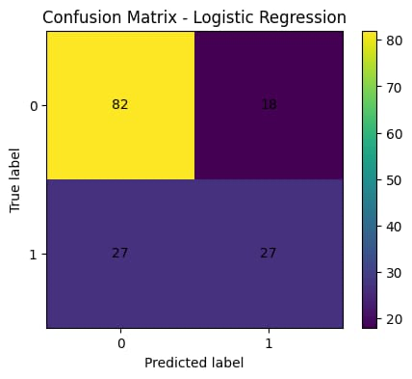
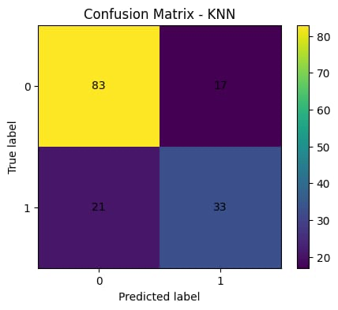

2.7 RESULT ANALYSIS AND COMPARISON
After completing the training and testing phases, a detailed analysis was performed to compare the performance of the three machine learning algorithms — DECISION TREE, K-NEAREST NEIGHBORS (KNN), and LOGISTIC REGRESSION — applied to the PIMA INDIANS DIABETES DATASET. The main objective of this analysis was to identify which algorithm demonstrated the highest predictive accuracy and most reliable performance in classifying patients as diabetic or non-diabetic. Each model was evaluated on the same test dataset using performance metrics such as accuracy, precision, recall, F1-score, and confusion matrix to ensure a fair comparison.

2.7.1 COMPARATIVE PERFORMANCE OVERVIEW
All three models performed efficiently, with accuracies ranging between seventy and seventy-five percent. Among them, the K-NEAREST NEIGHBORS (KNN) algorithm achieved the highest overall accuracy of 75.32 percent, demonstrating superior predictive power. The DECISION TREE followed with an accuracy of 72.07 percent, and LOGISTIC REGRESSION achieved 70.78 percent. These results clearly indicate that KNN performed the best overall, maintaining strong precision, recall, and F1-Score values, while Decision Tree and Logistic Regression provided consistent but slightly lower results. The balanced accuracy and stable classification results of KNN make it the most effective model for this medical dataset.

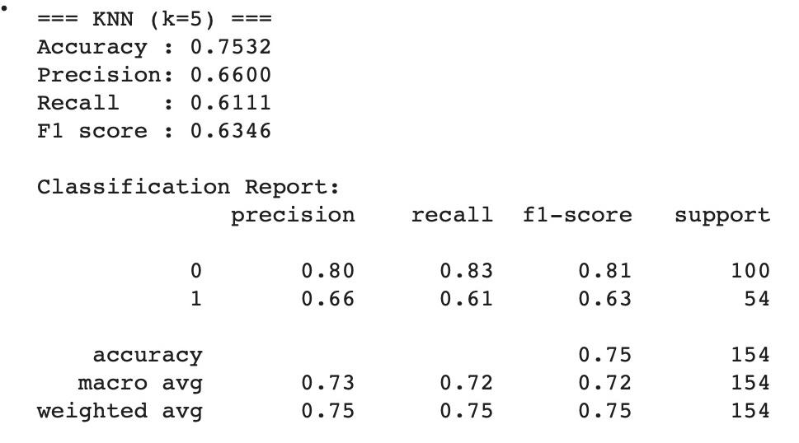
2.7.2 ANALYSIS OF KNN PERFORMANCE
Fig6: Classification Report of KNN

The K-NEAREST NEIGHBORS (KNN) model provided the most accurate and consistent results in this study. It performed exceptionally well because of its ability to capture non-linear relationships among features without assuming any predefined functional form. The KNN algorithm works by comparing new samples with previously known cases and predicting their class based on similarity. This makes it highly effective for medical datasets where feature relationships are often complex. Since the data was standardized during preprocessing, all attributes contributed equally to the prediction, enhancing accuracy. The chosen value of k = 5 gave the best performance, reducing both overfitting and underfitting. KNN achieved the highest accuracy and balanced performance across all metrics, demonstrating reliability and robustness. Its precision and recall were well-aligned, showing that it not only identified diabetic patients accurately but also avoided misclassifying non-diabetic patients.

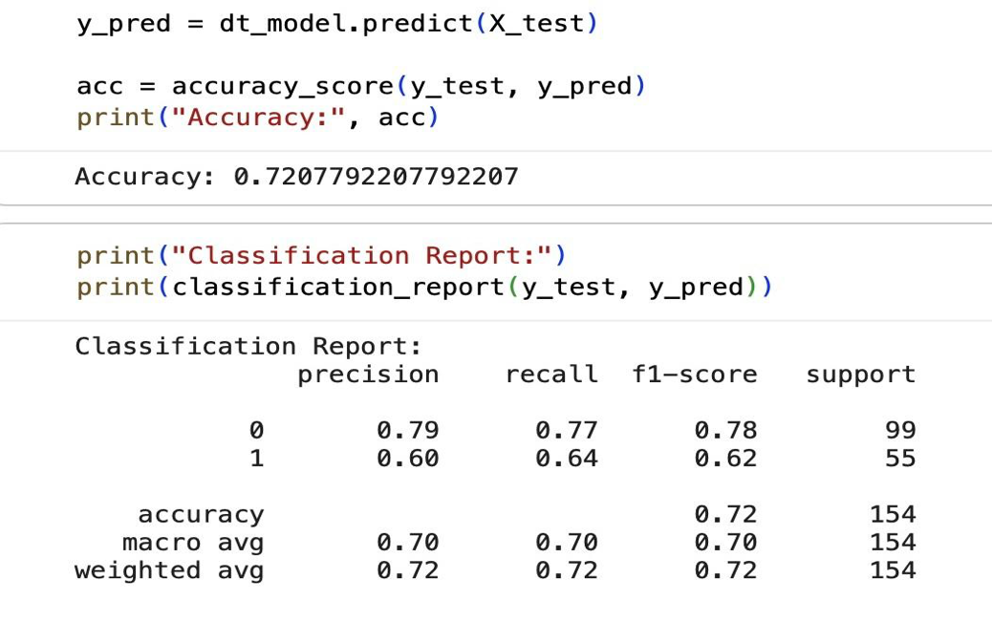
2.7.3 DECISION TREE MODEL INTERPRETATION
Fig7: Classification Report of Decision Tree Algorithm

The DECISION TREE CLASSIFIER achieved a satisfactory performance with an accuracy of approximately seventy-two percent. Its primary advantage lies in interpretability, as it provides a clear visual structure of the decision-making process. The tree diagram revealed that attributes such as glucose, BMI, and age were the most influential in determining diabetes risk. These features appeared near the top of the decision hierarchy, aligning with established medical understanding. The model effectively captured key decision boundaries, such as the fact that higher glucose levels or higher BMI values increase the probability of diabetes. However, Decision Trees are known to be sensitive to data variations and may overfit when trained on smaller datasets. Although regularization was applied by setting limits on tree depth, the model still showed slightly lower generalization compared to KNN. Nonetheless, its transparent decision-making process makes it highly useful for explaining results to non-technical stakeholders, particularly in healthcare environments.

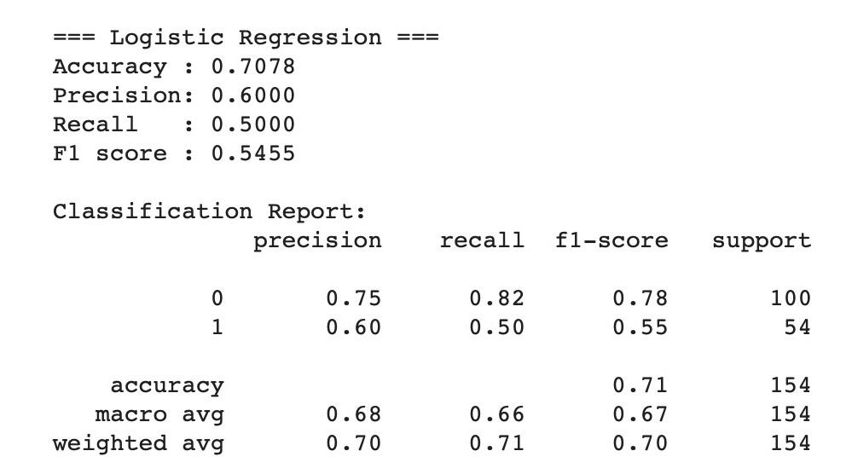
2.7.4 LOGISTIC REGRESSION MODEL EVALUATION
Fig8: Classification of LR algorithm

The LOGISTIC REGRESSION model performed consistently, achieving an accuracy of about seventy-one percent. Although its performance was slightly lower than the other two algorithms, it provided valuable insights into how individual features contribute to the final prediction. Logistic Regression is a linear model that estimates the probability of a patient being diabetic based on diagnostic features. The model coefficients revealed the positive relationship between glucose, BMI, and age with the likelihood of diabetes. In other words, as these parameters increased, the probability of diabetes also rose. While it could not capture non-linear dependencies present in the dataset, it offered the most interpretable results, making it a suitable model for understanding the influence of different medical attributes on diabetes prediction.

2.7.5 COMPARATIVE INTERPRETATION
Comparing all three algorithms reveals distinct strengths and limitations. KNN emerged as the top-performing model with the highest accuracy and balanced metrics, effectively handling the non-linear patterns in the data. It was able to identify diabetic and non-diabetic patients with strong consistency and minimal misclassification. The DECISION TREE model, although slightly less accurate, offered an easily interpretable structure that helps explain the reasoning behind predictions. This feature is particularly valuable in medical analytics, where understanding decision logic is crucial for practitioner trust and validation. LOGISTIC REGRESSION, while the simplest among the three, provided a transparent statistical view of the problem. It confirmed known medical correlations such as the impact of glucose levels and BMI on diabetes risk. Even though its predictive performance was lower, it remains a dependable and explainable baseline model.

2.7.6 PRACTICAL IMPLICATIONS
The results of this project clearly demonstrate that machine learning models can be used effectively to assist in the early detection of diabetes. Each model contributes unique strengths to the medical prediction process. The KNN algorithm’s high accuracy and balanced performance make it suitable for building automated screening tools that can provide preliminary assessments of diabetes risk. The DECISION TREE model, with its clear interpretability, can support doctors and analysts by showing the reasoning behind predictions. The LOGISTIC REGRESSION model, although simpler, provides valuable statistical insights into the significance of each parameter. Overall, the findings emphasize the growing potential of machine learning in healthcare, particularly in predictive diagnosis systems. With further optimization and larger datasets, such models can support medical professionals in decision-making and improve patient outcomes.

2.8 IMPLEMENTATION ENVIRONMENT
The implementation of this project was carried out in a modern, cloud-based computing environment that provided all necessary tools and resources for executing machine learning models efficiently. The environment was selected to ensure high computational speed, easy collaboration, and access to essential Python libraries for data analysis and visualization.
The project was implemented using PYTHON as the programming language, due to its simplicity, versatility, and extensive collection of libraries for data science and machine learning. The development work was performed on GOOGLE COLAB, a free, cloud-hosted Jupyter notebook service provided by Google. It allowed seamless execution of Python code without requiring any local setup and supported GPU acceleration for faster processing.

2.8.1 SOFTWARE TOOLS AND LIBRARIES USED
Several Python libraries were utilized during the development of this project:
- PANDAS: Used for data handling, manipulation, and cleaning. It provided efficient structures such as DataFrames to store and process the diabetes dataset.
- NUMPY: Used for numerical operations and array manipulation, enabling fast mathematical computations.
- SCIKIT-LEARN (SKLEARN): The primary machine learning library used for model implementation. It provided built-in classes for Decision Tree, KNN, and Logistic Regression, as well as functions for performance evaluation such as train-test split, classification report, and confusion matrix.
- MATPLOTLIB AND SEABORN: Used for data visualization, allowing creation of graphs such as heatmaps, bar plots, and histograms to understand feature relationships and model performance visually.
- GOOGLE COLAB: Served as the coding platform, offering cloud-based execution, storage integration with Google Drive, and a user-friendly notebook interface.

2.8.2 HARDWARE SPECIFICATIONS
Since Google Colab is a cloud environment, the computation was performed on virtual hardware provided by Google servers. However, typical system specifications during execution included:
- Processor: Intel Xeon (virtualized 2.20 GHz)
- Memory (RAM): 12 GB
- Storage: Cloud-based allocation with temporary runtime disk space
- GPU: Optional NVIDIA Tesla T4 (when enabled)
These specifications ensured smooth execution of training and testing phases, even when processing multiple algorithms.

2.8.3 SYSTEM DESIGN AND EXECUTION FLOW
The overall system followed a structured workflow:
- Import the necessary Python libraries.
- Load the diabetes dataset (CSV format) into the environment using pandas.
- Clean and preprocess the data (handle missing values, scale features).
- Split the data into training and testing sets (80:20 ratio).
- Train three models — Decision Tree, KNN, and Logistic Regression — on the training data.
- Predict outcomes on the test set and evaluate using accuracy, precision, recall, and F1-score.
- Compare results and identify the model with the best accuracy.
- Visualize performance using charts and confusion matrices.
This workflow ensured systematic execution from data loading to model evaluation, ensuring replicable and efficient results.

2.9 FLOW OF EXECUTION / WORKING OF MODEL
The working of the project follows a systematic flow that ensures the machine learning process is both efficient and reproducible. Each step has been carefully designed to maintain data integrity, optimize performance, and ensure accurate prediction outcomes. The complete workflow can be divided into several key phases, from data collection to result visualization.

STEP 1 – DATA COLLECTION AND IMPORT
The first step involved obtaining the Pima Indians Diabetes Dataset from Kaggle, which contains diagnostic measurements of female patients, such as glucose level, BMI, and age. The dataset was downloaded in CSV format and imported into the Google Colab environment using the pandas library. This step ensured that the data was properly loaded and accessible for further processing.

STEP 2 – DATA PREPROCESSING
Once the dataset was imported, it underwent several preprocessing steps to prepare it for model training. This included handling missing or zero values, standardizing feature scales using StandardScaler, and verifying data types. Proper preprocessing helped eliminate inconsistencies and ensured that all features contributed equally to the training process.

STEP 3 – DATA SPLITTING
The dataset was divided into two subsets — training data and testing data — using the train_test_split() function from scikit-learn. The training set, comprising 80% of the data, was used to train the models, while the remaining 20% was used to evaluate their predictive performance. The split was stratified to maintain a balanced ratio of diabetic and non-diabetic cases.

STEP 4 – MODEL TRAINING
Three supervised learning algorithms were trained on the training dataset — Decision Tree, K-Nearest Neighbors (KNN), and Logistic Regression. Each model learned to recognize patterns and relationships between the diagnostic measurements and the outcome variable.
- The Decision Tree built a hierarchical structure of decision rules based on the most informative features.
- The KNN algorithm classified samples by comparing their proximity to other data points in the feature space.
- The Logistic Regression model computed the probability of diabetes using a linear combination of features.
Training was performed in Google Colab using functions provided by scikit-learn, ensuring consistent implementation and reproducibility.

STEP 5 – MODEL TESTING
Once the models were trained, they were tested on unseen data from the test set to evaluate their ability to generalize. Each model generated predictions, which were compared to the actual values in the dataset. Testing helped identify how well each algorithm performed in real-world scenarios and avoided overfitting.

STEP 6 – PERFORMANCE EVALUATION
The predictions from each model were assessed using multiple performance metrics, including Accuracy, Precision, Recall, F1-Score, and Confusion Matrix. These metrics were calculated using scikit-learn’s built-in functions. The results showed that KNN achieved the highest accuracy (75.32%), outperforming the other models.

STEP 7 – RESULT COMPARISON AND VISUALIZATION
Finally, the performance results of all three models were compared. Visualization tools like Matplotlib and Seaborn were used to generate bar charts, confusion matrices, and other plots that clearly illustrated each model’s accuracy and classification behavior. These visual representations helped interpret the comparative strengths of each algorithm effectively.
The entire workflow, from data loading to performance visualization, was executed seamlessly within Google Colab, leveraging its computational efficiency and simplicity.

CHAPTER 3: RESULTS AND DISCUSSION

This chapter presents the final outcomes obtained from the implementation and evaluation of the three machine learning algorithms — Decision Tree, K-Nearest Neighbors (KNN), and Logistic Regression — applied to the Pima Indians Diabetes Dataset. The results were analyzed in terms of predictive performance, model behavior, and practical relevance in the context of diabetes prediction.

3.1 OVERVIEW OF RESULTS
Each algorithm was trained and tested using the same preprocessed dataset to ensure fairness in evaluation. The performance of each model was measured using key metrics such as accuracy, precision, recall, F1-score, and confusion matrix.
Among all models tested, the KNN algorithm achieved the highest overall performance, with an accuracy of 75.32%, followed by the Decision Tree model with 72.07% and Logistic Regression with 70.78%.
The performance metrics confirmed that KNN demonstrated both high predictive accuracy and a stable balance between identifying diabetic patients and minimizing false predictions. The Decision Tree and Logistic Regression models also performed satisfactorily, validating the reliability of machine learning techniques in medical data analysis.
The results can be summarized as follows:
- KNN: Most accurate and balanced model for diabetes prediction.
- Decision Tree: Good interpretability, moderate accuracy.
- Logistic Regression: Statistically explainable but less adaptable to non-linear patterns.

3.2 DISCUSSION OF FINDINGS
The K-Nearest Neighbors (KNN) model emerged as the most effective algorithm for predicting diabetes due to its ability to capture both linear and non-linear relationships in the data. Since the dataset was standardized, all diagnostic features contributed equally to the prediction process, enhancing model reliability. The KNN model’s simplicity, non-parametric nature, and strong generalization made it particularly well-suited for this medical dataset.
The Decision Tree model achieved competitive performance and offered a major advantage in interpretability. Its hierarchical structure of decisions clearly illustrated how each medical parameter influenced the classification outcome. The model revealed that glucose level, BMI, and age were the most influential attributes — insights that align with known clinical risk factors for diabetes. However, the Decision Tree exhibited minor overfitting tendencies, which may have limited its generalization on unseen data.
The Logistic Regression model provided a solid baseline for comparison. Although it achieved slightly lower accuracy, it delivered clear probabilistic interpretations of the relationship between input variables and diabetes outcomes. This made it useful for medical applications where interpretability and simplicity are valued more than maximum accuracy.
Overall, the comparative analysis showed that all three algorithms could predict diabetes with reasonable accuracy, demonstrating the applicability of machine learning to healthcare analytics. The results also highlighted that the effectiveness of each algorithm depends on the nature of the data and the balance between interpretability and predictive power.

3.3 KEY OBSERVATIONS
- The KNN model outperformed other models in both accuracy and balanced classification metrics.
- Decision Tree provided strong interpretability and highlighted the most critical features influencing diabetes risk.
- Logistic Regression produced consistent but less flexible results due to its linear nature.
- Glucose, BMI, and Age consistently appeared as the most important predictive attributes across all models.
- Preprocessing and feature scaling significantly improved model stability and accuracy.
These findings emphasize that data quality, preprocessing, and parameter tuning play a vital role in achieving high-performing predictive models. The successful use of three distinct algorithms also demonstrates the versatility of machine learning in healthcare prediction systems.

3.4 SUMMARY
The experiments successfully validated the predictive capability of machine learning algorithms for early diabetes detection. KNN emerged as the most accurate and reliable model, while Decision Tree and Logistic Regression contributed valuable interpretability and analytical understanding. The results indicate that machine learning can assist healthcare professionals in identifying at-risk patients more efficiently, ultimately enabling early intervention and preventive care.

CHAPTER 4: CONCLUSION
This project, “Diabetes Prediction Using Decision Tree, K-Nearest Neighbors (KNN), and Logistic Regression Classifiers,” was undertaken with the goal of developing a machine learning-based system capable of predicting the likelihood of diabetes in patients using diagnostic data. The study utilized the Pima Indians Diabetes Dataset, which contains medical parameters such as glucose level, BMI, insulin, age, and blood pressure.
The project successfully demonstrated how supervised learning algorithms can be applied to healthcare analytics for predictive diagnosis. The data was preprocessed, standardized, and divided into training and testing sets to ensure fair evaluation. Three machine learning algorithms — Decision Tree, KNN, and Logistic Regression — were implemented using Python in the Google Colab environment with libraries such as Pandas, NumPy, Scikit-learn, Matplotlib, and Seaborn.
Among the three models, the KNN algorithm achieved the highest accuracy of 75.32%, followed by Decision Tree with 72.07% and Logistic Regression with 70.78%. KNN demonstrated a strong balance between precision, recall, and F1-score, making it the most effective algorithm for this dataset. The Decision Tree model provided excellent interpretability and insight into key factors influencing diabetes, while Logistic Regression offered statistical clarity regarding feature relationships.
The findings of this project highlight the potential of machine learning in early disease detection and preventive healthcare. Predictive analytics can support medical practitioners by identifying at-risk patients efficiently, thus aiding timely intervention and reducing long-term health complications. The results also reaffirm the importance of data preprocessing, model selection, and performance evaluation in achieving accurate predictive outcomes.
Beyond its technical achievements, this project emphasizes the broader impact of integrating artificial intelligence into healthcare systems. By leveraging data-driven insights, such models can complement clinical decision-making, improve diagnostic efficiency, and contribute to the development of intelligent, patient-centered medical systems.
In conclusion, this project achieved its primary objectives — implementing and comparing multiple algorithms, identifying the most accurate model, and validating the feasibility of machine learning in diabetes prediction. The outcomes provide a strong foundation for future research, including the application of ensemble learning, deep neural networks, and real-time clinical integration to further enhance accuracy and usability in medical diagnostics.

CHAPTER 5: FUTURE SCOPE

Although the project “Diabetes Prediction Using Decision Tree, K-Nearest Neighbors (KNN), and Logistic Regression Classifiers” successfully achieved its objectives, certain limitations and potential areas of improvement have been identified. These limitations open several opportunities for future research and enhancement, which can further strengthen the accuracy, usability, and real-world impact of the system.
The current work primarily focused on comparing three supervised learning algorithms using the Pima Indians Diabetes Dataset. While the models performed effectively, future developments could expand the dataset, refine the algorithms, and enhance deployment capabilities to make the system more scalable and clinically applicable.

5.1 Limitations of the Study
Despite its success, the project faced some limitations that restricted the scope of its predictive capability.
- The dataset used, though well-structured, was limited in size and diversity, representing only a specific population group. As a result, the trained models may not generalize equally well to other demographic or regional datasets.
- The study considered only a limited set of medical parameters such as glucose, BMI, insulin, and age. Real-world diagnosis often involves more variables, including lifestyle factors, genetic predisposition, and family medical history, which were not included in this dataset.
- The algorithms used were relatively simple supervised classifiers. While effective, they may not fully capture complex, nonlinear patterns that more advanced models, such as ensemble or deep learning techniques, could identify.
- The project focused purely on model development and testing within a controlled environment. It did not extend to building a user interface or integrating the predictive model into a clinical workflow.
These limitations provide insight into areas where future work can significantly improve the project’s scope and practical value.

5.2 Future Scope and Enhancements
To overcome the current constraints and enhance the system’s performance, several future improvements are proposed:
- Dataset Expansion: Incorporating larger, multi-regional datasets would improve the model’s generalization and reduce potential biases. Including diverse medical records from different populations would enhance the model’s reliability in global healthcare applications.
- Additional Features: Adding more medical and lifestyle parameters such as cholesterol levels, diet, physical activity, blood pressure history, and genetic data could lead to more comprehensive and accurate predictions.
- Advanced Algorithms: Future work could implement ensemble learning methods (Random Forest, Gradient Boosting, XGBoost) or deep learning models (ANNs, CNNs) to improve accuracy and capture more complex data relationships.
- Real-Time Application: Developing a web or mobile application could allow patients or healthcare professionals to input data and receive instant diabetes risk assessments.
- Integration with Healthcare Systems: Linking the model with electronic health records (EHR) could enable automated, real-time updates and continuous learning as new medical data becomes available.
- Explainable AI (XAI): Implementing explainability features would make model predictions more transparent and interpretable, building greater trust among medical practitioners.
- Cloud Deployment: Hosting the system on cloud platforms such as Google Cloud or AWS would improve scalability, accessibility, and performance for large-scale usage.

BIBLIOGRAPHY

[1] Kaggle, Pima Indians Diabetes Database, 2024. [Online]. Available: https://www.kaggle.com/datasets/uciml/pima-indians-diabetes-database
[2] UCI Machine Learning Repository, Pima Indians Diabetes Dataset, 2024. [Online]. Available: https://archive.ics.uci.edu/ml/datasets/pima+indians+diabetes
[3] Scikit-learn Developers, Scikit-learn: Machine Learning in Python, 2024. [Online]. Available: https://scikit-learn.org
[4] Google Research, Google Colaboratory (Colab): A Cloud-Based Python Environment, 2024. [Online]. Available: https://colab.research.google.com
[5] W. McKinney, Python for Data Analysis: Data Wrangling with Pandas, NumPy, and IPython, O’Reilly Media, 2017.
[6] Numpy Developers, NumPy Documentation, 2024. [Online]. Available: https://numpy.org/doc/
[7] Pandas Developers, Pandas Documentation, 2024. [Online]. Available: https://pandas.pydata.org/docs/
[8] Matplotlib Developers, Matplotlib: Visualization with Python, 2024. [Online]. Available: https://matplotlib.org
[9] Seaborn Developers, Seaborn: Statistical Data Visualization, 2024. [Online]. Available: https://seaborn.pydata.org
[10] GeeksforGeeks, Understanding K-Nearest Neighbors (KNN) Algorithm in Machine Learning, 2023. [Online]. Available: https://www.geeksforgeeks.org/k-nearest-neighbors-algorithm-in-machine-learning
[11] GeeksforGeeks, Decision Tree Algorithm Explained with Examples, 2023. [Online]. Available: https://www.geeksforgeeks.org/decision-tree-introduction-example
[12] Towards Data Science, A Beginner’s Guide to Logistic Regression in Machine Learning, 2023. [Online]. Available: https://towardsdatascience.com/understanding-logistic-regression-in-machine-learning
[13] Analytics Vidhya, Implementing KNN, Decision Tree, and Logistic Regression in Python, 2023. [Online]. Available: https://www.analyticsvidhya.com/blog/2021/06/implementing-knn-decision-tree-and-logistic-regression-in-python
[14] StatQuest, Understanding Classification Metrics: Accuracy, Precision, Recall, and F1-Score, 2023. [Online]. Available: https://statquest.org/video-index/accuracy-precision-recall-f1-score/
[15] Python Software Foundation, Python Documentation, 2024. [Online]. Available: https://www.python.org/doc
[16] World Health Organization (WHO), Global Report on Diabetes, 2023. [Online]. Available: https://www.who.int/publications/i/item/9789241565257
[17] J. Al-Muhtadi et al., “Machine learning approaches for early detection of diabetes mellitus,” Biomedical Signal Processing and Control, vol. 70, 103001, 2021. [Online]. Available: https://www.sciencedirect.com/science/article/pii/S1746809421001772
[18] M. Patel, M. Shah, and S. Thakkar, “Comparative analysis of machine learning algorithms for diabetes prediction,” International Journal of Engineering Research & Technology (IJERT), vol. 11, no. 6, 2022. [Online]. Available: https://www.ijert.org/research/comparative-analysis-of-machine-learning-algorithms-for-diabetes-prediction
[19] F. Jabeen and M. Rajesh, “Performance evaluation of KNN and logistic regression for medical data classification,” Journal of Emerging Technologies and Innovative Research (JETIR), vol. 8, no. 8, 2021. [Online]. Available: https://www.jetir.org/view?paper=JETIR2108129
[20] H. Yadav and P. Singh, “Application of machine learning algorithms for diabetes prediction and risk assessment,” Proceedings of the International Conference on Data Science and Intelligent Applications (ICDSIA), Pune, India, Feb. 2023, pp. 89–95. [Online]. Available: https://ieeexplore.ieee.org/document/10075845

